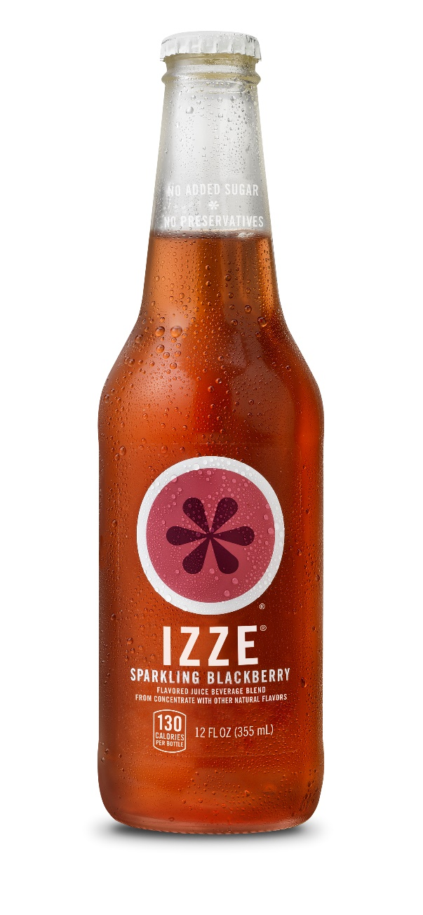

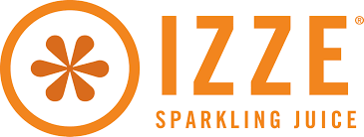

**Media Plan 2016**

**By: Ashley Dixon, Tiana Garcia, Jayme Wilson and Joseph Valentin**

**Executive Summary**

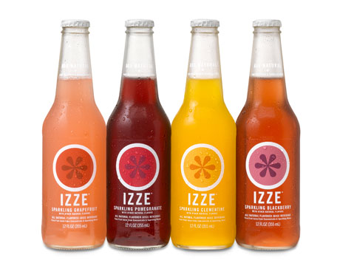IZZE was founded in February 2002, by Todd Woloson and Greg Stroh, in Boulder, Colorado. The sparkling fruit juice is based on European sodas the two have tried while traveling in Europe. Stroh and Woloson tried to capture the sophisticated fruit flavors and make a soda similar to the European ones for America. The two agreed that the name of the brand should be called IZZE after Isabelle, the eldest daughter of co-founder Todd Woloson. The IZZE brand also combined with Todd and his wife, Eliza’s, non-profit, Global Education Fund. The non-profit organization, Global Education Fund helps educate kids because they believe that educating kids secures a better future for the world.

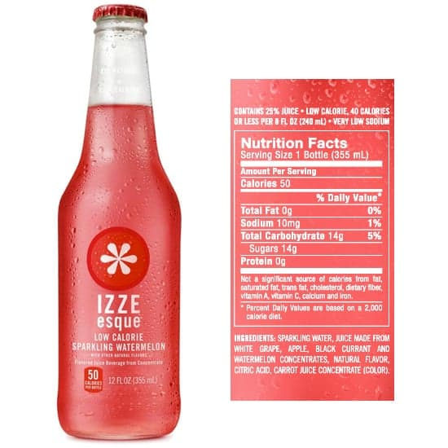PepsiCo acquired IZZE, but kept founders Woloson and Stroh on the brand team. The caloric content is equal to or lower (depending on the flavor) than other juice drinks, sodas, or new age beverages on the market. But most importantly, the sugars/carbohydrates in IZZE are naturally occurring, and come from wholesome, natural sources. IZZE is a great substitute for soda. It has a great carbonated, fruit flavored taste, which was inspired from fruit flavored drinks in Europe.

**Current Marketing situation**

IZZE's sales have been achieved primarily through a push strategy. The founders have successfully pushed the IZZE brand into households by achieving distribution in retailers such as Whole Foods and Trader Joe’s. They have also had periodic case sales through big box stores like Costco, they sell on Amazon, and communicate through social media. IZZE is getting some local and regional retailers to give their product valuable shelf space. IZZE’s strongest sales are in natural food stores and high-end gourmet markets. IZZE’s current marketing objective is to become national established brand. IZZE’s top competitors are carbonated soft drinks, fruit juices/fruit flavored drinks, non-carbonated soft drinks, bottled water and vegetable juices. Below is the shows the competitive market spending in 2013. Carbonated soft drinks have the biggest marker share, therefore being IZZE’s biggest competition.

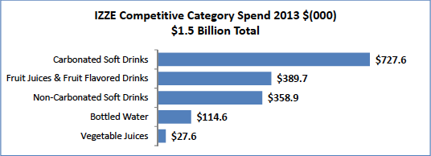

**Swot analysis**

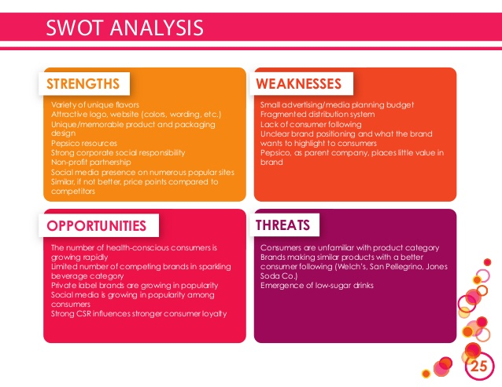

**Analysis of target markets**

We plan to target women 18-44 with active lifestyles. People who have values in health and fitness. This is a perfect audience because it is again a great substitute for people who don't want to drink a soda. Great for individuals starting to diet and want less calories in a flavored and carbonated drink.

**Copy Strategy**

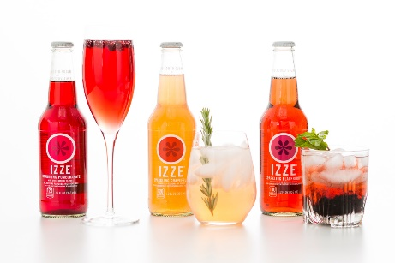IZZE is a product that is made with natural sugars and fruit, one of our creative execution ideas is to focus on quality and why this product is a healthier option than other carbonated soft drinks and all-natural fruit drinks. IZZE contains 70% pure fruit juice with no refined sugars, caffeine, high fructose corn syrup, preservatives or artificial flavors. This is a product that can explain to potential consumers on how all-natural ingredients are healthier than “diet” sodas with artificial sweeteners. We want to establish IZZE as a “healthy alternative” brand to market to those who are health conscious. We also will use the healthy attributes to promote those with active, adventurous lifestyles. We want to relay the message that those who are on the go all the time need an IZZE with them.

IZZE is in a great position to capitalize on the decline of interest in unhealthy soft drinks. It is primarily is stationed in the United States and is the only all-natural drink owned by a major corporation (PepsiCo). IZZE is also extremely affordable considering all the all-natural ingredients the drink contains and that it is organic. Other products like this tend to be expensive.  All these qualities give IZZE a competitive advantage and we want to use those competitive strengths to meet the goals of the company.

The second creative execution we want to portray to potential consumers is that IZZE is a new, fun, and hip drink for parties and celebrations for our younger generation consumers. When celebrating the New Years, graduations or birthdays, people can use IZZE as a mixer with alcohol instead of soda in order to remain healthier but still have fun and enjoy celebrating an occasion with their friends/family.

**Media plan**

**Media Objectives:**

**Reach:** To obtain an average reach of 80 throughout the national campaign during pulsing months ((November-February, June- August) and 95 throughout the spot campaign. To maintain an average reach of 80 throughout the campaign in the months we are doing minimal consistent advertising.

**Frequency:** To obtain an average frequency of two during national pulsing months and one during spot pulsing months. To obtain an average frequency of two during resting months we will have consistent advertising.

**Continuity:** Pulsing: Consistent messaging with times of increased exposure (November-February, June-August).

**Flexibility:** To obtain a campaign with high flexibility.

**Creative strategy implications of media selected:** Using radio, Television, and Magazines in order to optimize reach throughout the campaign.

Budget: No more than 18 Million throughout the duration of the campaign.

**Media objective rationale:**

We want to optimize reach because it will maximize the amount of potential consumers that see our advertisements and help bring awareness of our product. We are optimizing reach because we are trying to establish the brand and take it national. Our focus isn’t to optimize frequency because we are more concerned with the getting more people to see our advertisements rather than how many times a person sees our advertisements so we the objective we set for average frequency is lower than average. A pulsing strategy will be best for our campaign because with the changing of seasons and our product being a cold beverage, we think that IZZE will be more popular and have more recognition in the warmer months than during the colder months. We want to increase exposure June-August to promote IZZE during the times that their sales are high. We want to increase exposure November-February to increase sales during those time and implement our creative execution idea. We would like to obtain a high flexibility because it would offer IZZE wiggle room in the media plan to make changes they see as fit or necessary.

With the use of National Television, it would help optimize reach and bring more awareness nationally around prime time hours spreading the message that IZZE is a fun, new and hip product that younger generations can drink. We also want to send that message that IZZE will still remain healthy throughout the entire year. Radio is intended to help grab attention to those other potential health oriented customers who don’t watch television on a regular basis. Radio is also there to help reiterate the national television advertisements to our target audience through a different type of media channel and gain more familiarity as we will be sending the same media messages throughout all the media classes we have chosen. Magazines show our target audience that IZZE is a new, fun and hip product that is health oriented and is becoming the new “trend” within their community and generation. Because we have a lower budget than most, we want to make sure that we utilize the whole 18 million throughout the 12 month campaign.

**Media Strategy:**

**Reach, Frequency and GRP Strategy -** Having all media outlets in national spots would help IZZE: accomplish their goals, increase their brand awareness, and maintain Reach, Frequency, and GRPs objectives. We achieved a reach of 75.6 during our campaign and an average of 2.2 frequency. The total GRPs we used was 1,155 with 735 GRPs in national areas only and 420 GRPs in spot markets.

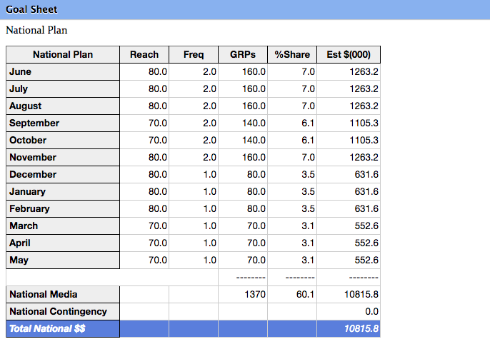

**Target audience and media mix -** We chose adults ages 18-49 in the Media Flight Plan because, according to the research data, they were more likely to be interested in IZZE. Also in the data, we saw that health conscious people were more likely to read health magazines, watch television during prime time, use social media, and listen to the radio during their drive to and from work. People in this age demographic are also more likely to live active and adventurous lifestyles which allows us to achieve the goals of the media plan. Another advantage to this specific target audience is that they are likely to throw holiday parties and be health conscious around New Years.

**Scheduling and timing strategy -** We used 15 second spots throughout all of our advertisements in order to save money and buy more spots for each medium since we wanted to utilize our budget in the correct way. We are pulsing through June through August because during the summer people are more active, adventurous and health conscious. Also we used a pulsing strategy in November through February. We decided on this because we want people to use our product during holiday parties as a healthier mixture for alcohol. The reason why we chose these media types was because adults have daytime jobs would be likely to use these media vehicles to get information on products they like.

**Media budget strategy -** Our overall budget was $18,000,000 throughout the year campaign. $1,741,300 was spent during pulsing months, while $1,153,400 was spent in non-pulsing months. We chose this method because we wanted to allocate more of our budget during the months of increased exposure. For Television, we used an average of 7,898,300 to optimize reach. For radio we used an average of 870,300 because we were less cautious with frequency. Spending with magazines was an average of 9,296,800, which is what we wanted

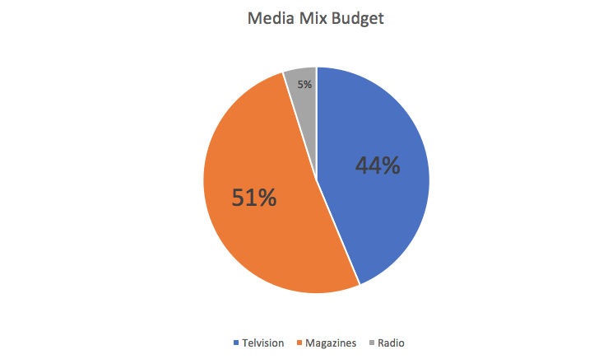because we think it will reach the more of our target audience.

**Geography strategy -** We chose our 10 spot markets based off of high CDI from the IZZE market data. Our ten spot markets are Miami, El Paso, Las Vegas, Fresno, New York, Chicago, Houston, Laredo, San Diego and Milwaukee. We decided to heavy up spot in order to optimize our overall reach throughout the campaign.

**Flowchart:**

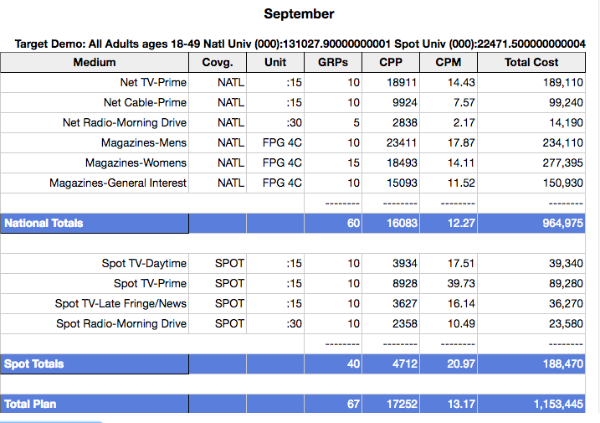

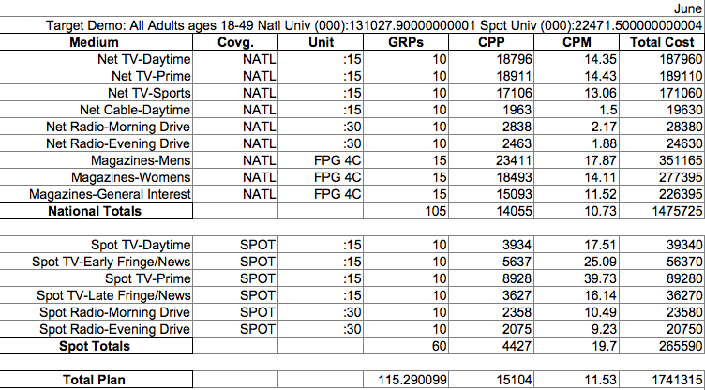

Above are charts that show our media and day part selections. The September chart summarizes our non-pulsing months, while our June chart summarizes our pulsing months.

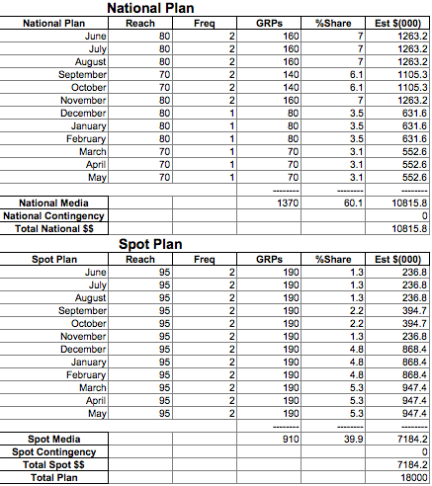

Above is the chart that shows our national and spot summaries for all media that was selected or considered.

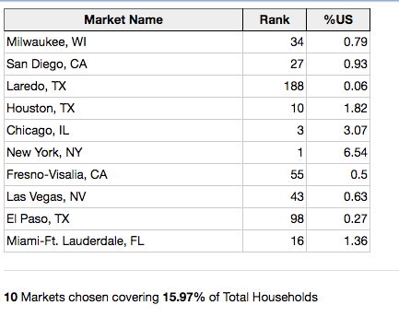

Above are the ten spot markets we decided to heavy up in.

**Conclusion**

After all the tests that we ran through the Media Flight Plan, we decided that a bigger budget was needed in order to reach our objectives of the company. Through all the research we’ve done, we decided the media vehicles that we chose were best suited for our target audience and the budget we were allocated. With our team members being a part of this generation, we believe that we have the skills and knowledge to cater to our target audience and their needs. With our creative strategies, we can accomplish the goals of the company.



